1. Create a new branchh called developBranch

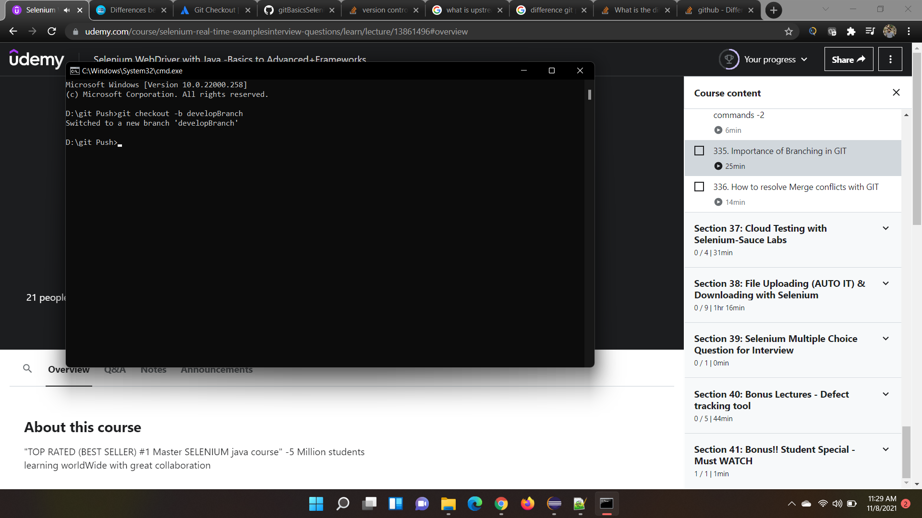

1. A branch is created in git

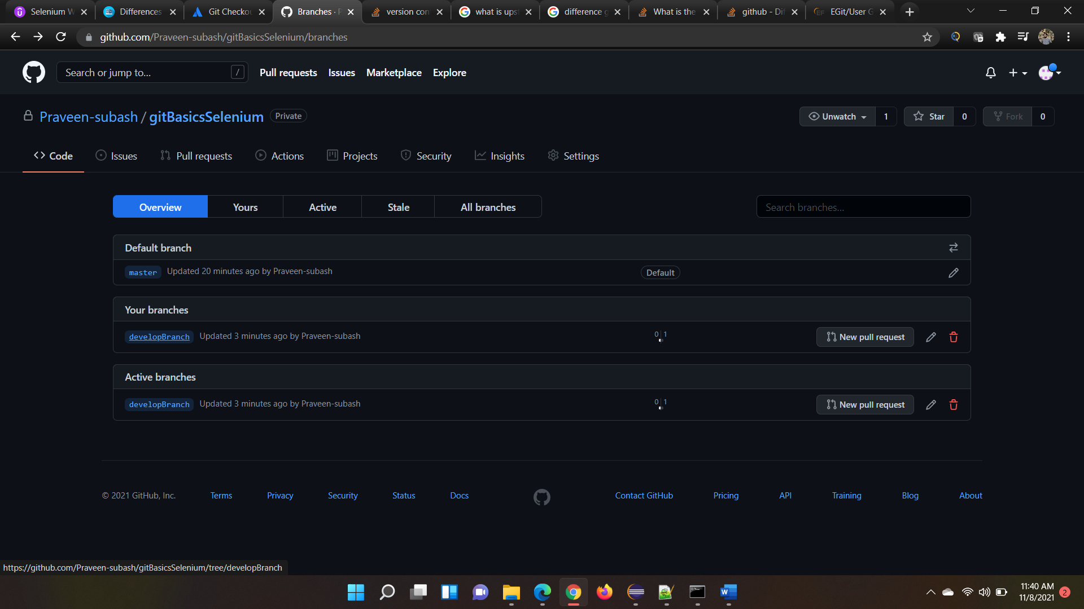

1. A new java file AddedGitBranch is added. Assume that new branch is created and changes are added

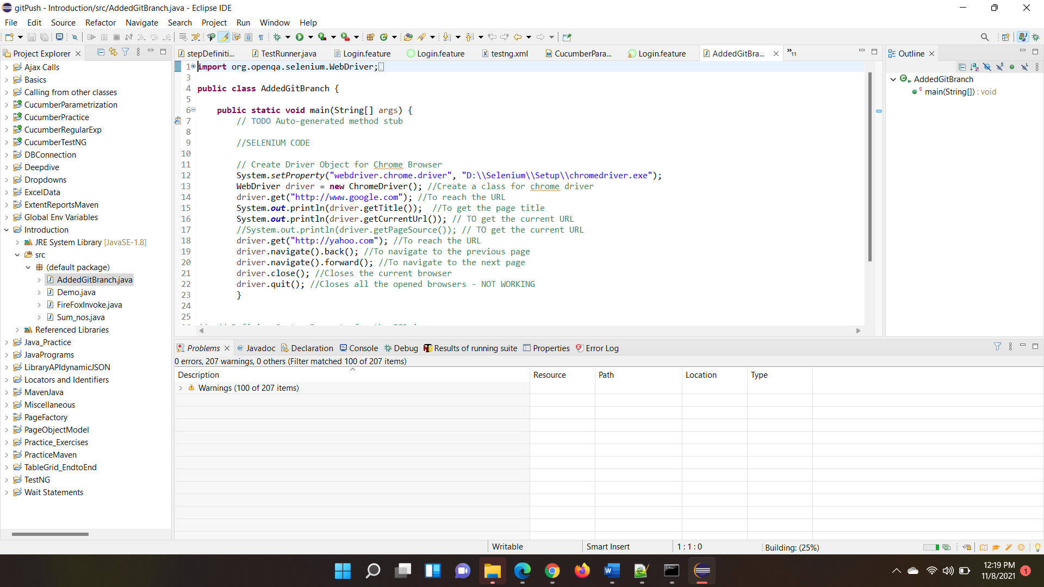

1. Add and commit as usual

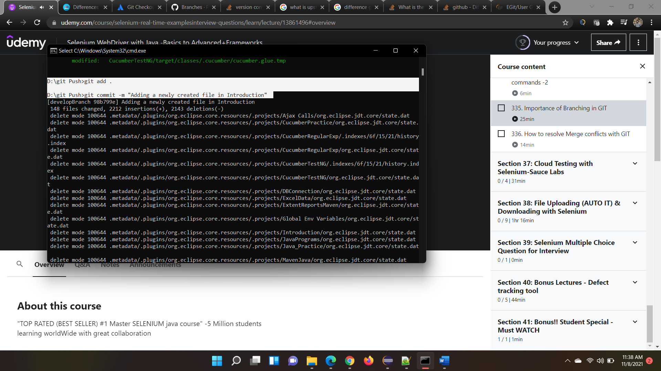

1. Push the code to developBranch by specifying the origin

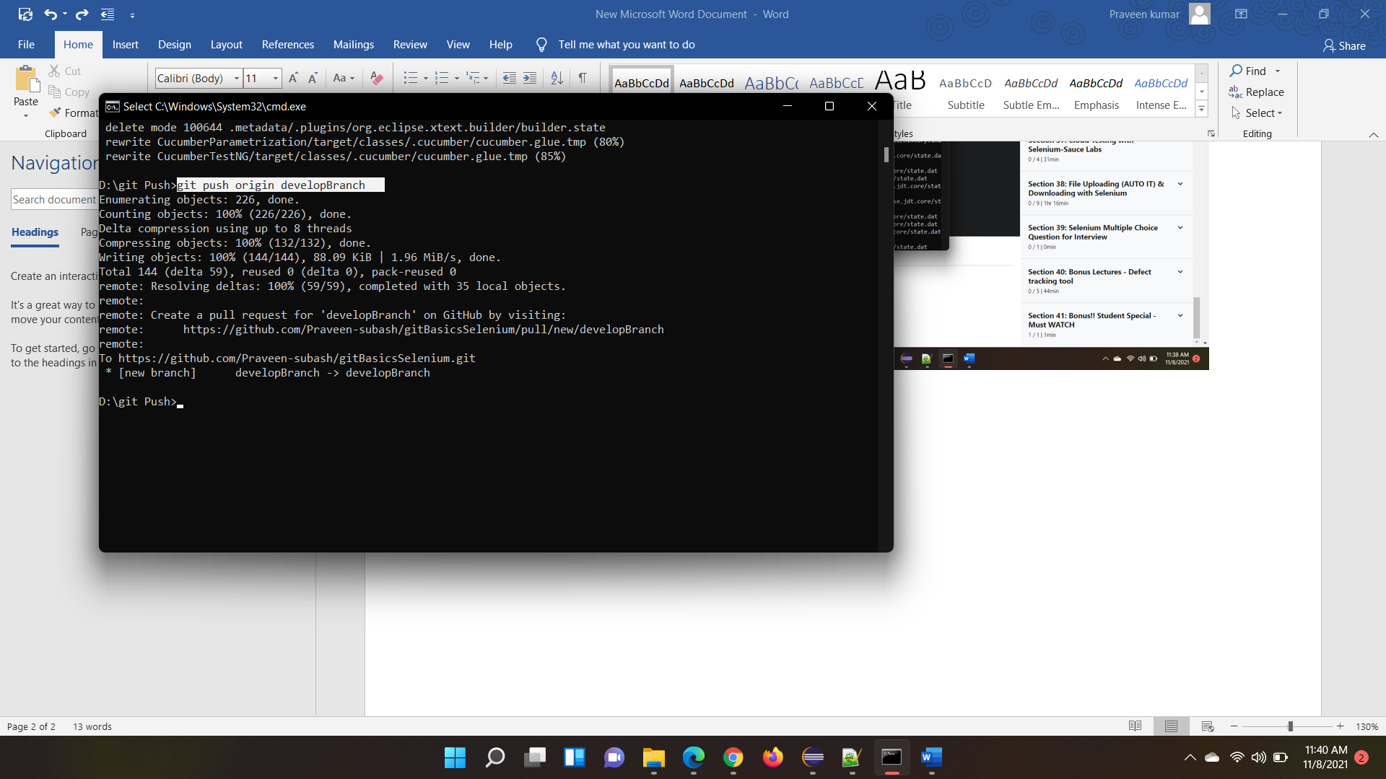

1. Now we have AddingGitBranch extra in Branch. Whereas we don’t have that in master. We are trying to merge that

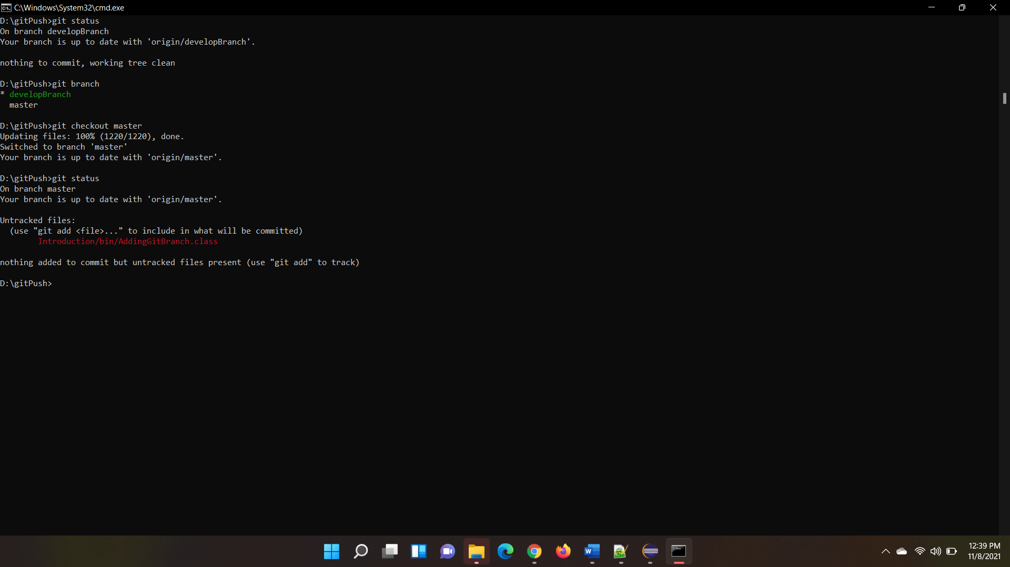

1. Now we are in master branch. We are merging developBranch with master as shown below

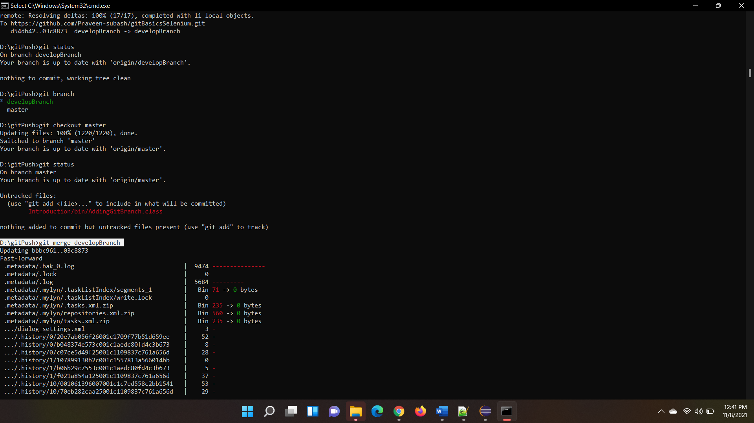

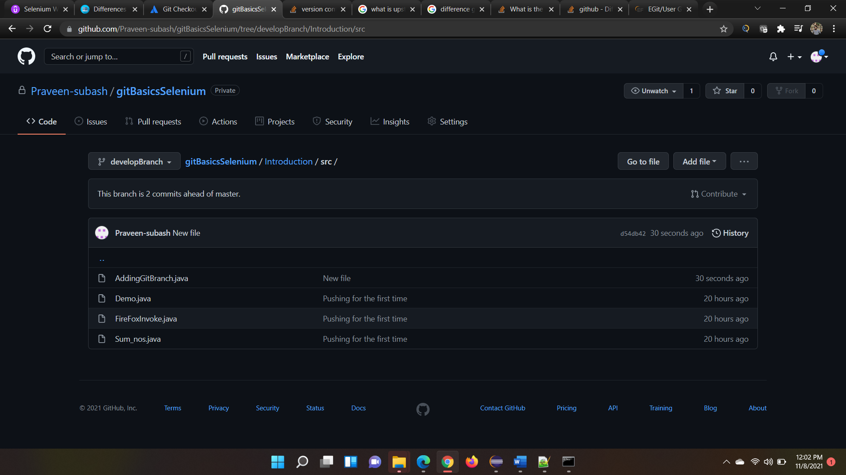

1. After merging only if we push the master branch, code gets merged